Hydrogen chloride rovibrational spectrum worksheet
The baseline corrected spectrum are shown below. You will need to obtain a spectrum like this in Excel, in order to read off the values of the rotational bands in the R branch. The raw data file is wvn_single_ref_sample.csv and can be downloaded in the virtual lab protocol. You will need to process the appropriate spectra. Please turn in your Excel document used for this part along with this worksheet.
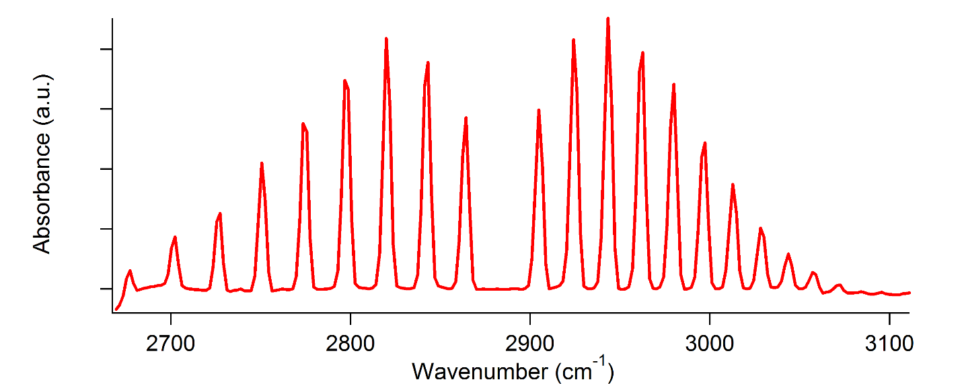
We can determine the rotational constant, $\tilde{B}$, and the anharmonic coupling constant, $α$, using the equation:
$${\tilde{ν}}_{obs}={\tilde{ν}}_{o}+2\left(\tilde{B} -α\right)m-αm^{2}$$
This equation uses the equation $m=J(J+1)$, which permits us to find a linear solution. Amazing that this works!
Calculations
- Using the appropriate raw data calculate an absorption spectrum. The reference is $I_{0}$ and the sample is $I$. Use Excel operations to calculate:

$$A=- \log_{10}\left(\frac{I}{I_{0}}\right)$$
We are not concerned with the magnitude of A, but rather the positions of the various absorption lines. Of course, the absorbance could be increased by increasing the HCl partial pressure, but it is arbitrary since we are not measuring the partial pressure. Leave this calculation on the first tab of your Excel spreadsheet to hand in. Then do the linear and quadratic regressions on the next two tabs.
- Using the absorbance data calculated from reference and sample in an Excel spreadsheet, tabulate the peaks in the R branch in Table 1. Table 1 has been moved down to the next page to make it easier to see the series of numbers.

Table 1. Peak values of the R branch in cm⁻¹.
m | peak
0
1
2
3
4
5
6
7
8

- First perform a linear regression on these data to obtain an estimate for the rotational constant. Keep in mind that the line spacing in each is 2$\tilde{B}$, where $\tilde{B}$ is the rotational constant in cm⁻¹. Clearly, the equation you will consider for this calculation cannot have a quadratic term. Thus, we set $α=0$ in the above equation to find:

$${\tilde{ν}}_{obs}={\tilde{ν}}_{o}+2\tilde{B} m$$

- From the linear regression parameters obtain the Q branch wave number, ${\tilde{ν}}_{0}$. __________

- Report the 95% confidence width for both $\tilde{B}$ and ${\tilde{ν}}_{0}$. _____________________________

- We can use these values to extract the bond length, $R$, and force constant, $k$. Just to remind you, the rotational constant is related to the internuclear distance of a diatomic, $R$:
$$\tilde{B}=\frac{h}{8πcI}=\frac{h}{8πcμR^{2}}$$

$I$ is the moment of inertia,
$$I=μR^{2}$$
and the reduced mass is
$$μ=\frac{m_{H}m_{Cl}}{m_{H}+m_{Cl}}$$

In these calculations, you should use MKS units for all quantities except for c, the speed of light. Here I recommend cm/second. The reason is that all of the MKS units will cancel out leaving you with cm⁻¹. $R=$ ___________________________________. (units!)
- Report the 95% confidence width for both $R$ using propagation of error. _____________

- Calculate the force constant for the HCl harmonic oscillator model. Please report your answer in Newtons/meter. Note that force constants obtained using these methods are widely used in molecular mechanics and dynamics force fields. The force constant is given by:
$$k=μ4π^{2}c^{2}{\tilde{ν}}_{0}^{2}$$

Here too, use cm/second for c in order to cancel the units of cm⁻¹ for ${\tilde{ν}}_{0}$.
$k=$________________________________________. (units!)

- Conduct a quadratic regression
$$\tilde{ν}=a_{0}+a_{1}m+a_{2}m^{2}$$
Relate the three parameters to the quantities $α,$ $\tilde{B},$ and ${\tilde{ν}}_{0}$. Remember that for a quadratic regression you need to include an extra column of values corresponding to $m^{2}$. I leave it to you put those values in. This is how your table should look in Excel.
m | m² | peak
0
1
2
3
4
5
6
7
8

Once you have the table with both columns (assume that they are A and B) you may use the LINEST function in manner similar to linear regression, but identifying both A and B as dependent variables.
$$LINEST=(C1:C9;A1:B9;1;1)$$

- Did the values of $\tilde{B}$ or ${\tilde{ν}}_{0}$ change by more than the 95% confidence limit you found for the linear regression?

- Name three vibrational modes of polyatomic molecules that also have rovibrational spectra.

